Name: Saniya Galib Tamboli

Email: [saniyagtamboli2412@gmail.com](mailto:saniyagtamboli2412@gmail.com)

Batch: DWS_B5_25VID2550

User Id: 34749

Date: 11/08/2025

**ASSIGNMENT**

* **Deployment of an App Using PSAppDeployToolkit (PSADT)**

**Step 1: Download the Full Toolkit**

First, I downloaded the complete PSAppDeployToolkit package from its official website. It’s important to get the full version, not just the module, because the full package has all the files and folders needed.

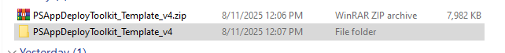

Fig.1 PSAppDeployToolkit File

**Step 2: Extract the Files**

Then, I extracted the zip file to a folder on my computer. Inside, there were different files and folders like Deploy-Application.ps1, Files, and SupportFiles.

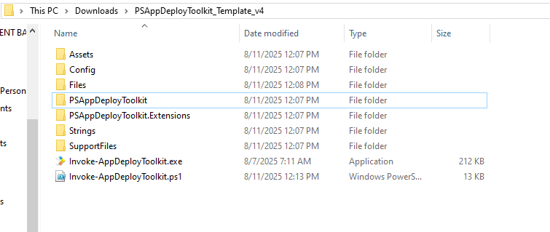

Fig.2. Extracting the files in downloaded folder

**Step 3: Add the Installer**

I put the application installer file (for example, Google Chrome’s MSI) inside the Files folder. If I had any extra files, like bookmarks or shortcuts, I’d put those in SupportFiles.

Execute-MSI -Action 'Install' -Path 'MSI_Wrapper_25_0_54_0.msi'

**Step 4: Edit the Deployment Script**

Next, I opened the Deploy-Application.ps1 file in a text editor. I filled in details like the app name and version. Then, I wrote simple commands for installing and uninstalling the app using built-in toolkit functions.

Execute-MSI -Action 'Install' -Path 'MSI_Wrapper_25_0_54_0.msi'

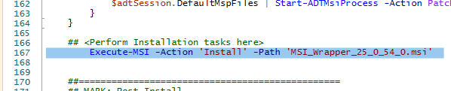

Fig.3 Editing Deployment Script (1)

Execute-MSI -Action 'Uninstall' -Path 'MSI_Wrapper_25_0_54_0.msi'

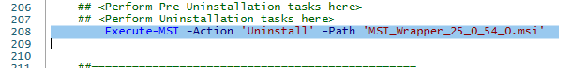

Fig.4 Editing Deployment Script (2)

**Step 5: Test Locally**

Before uploading, I tested the installation on my own PC to make sure it worked. Since Intune runs apps as the SYSTEM user, I used a tool called PsExec to simulate that environment and run the install as SYSTEM.



Fig.5 Testing Locality

C:\Users\innam\OneDrive\Desktop>C:\Users\innam\Downloads\PSAppDeployToolkit_Template_v4\Invoke-appDeployToolkit.exe Uninstall

C:\Users\innam\OneDrive\Desktop>C:\Users\innam\Downloads\PSAppDeployToolkit_Template_v4\Invoke-appDeployToolkit.exe Install

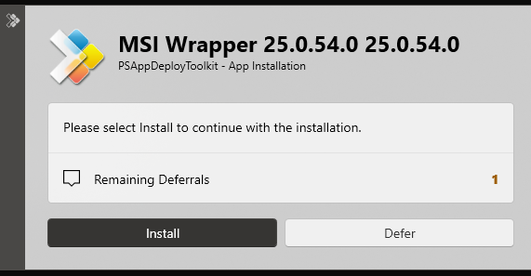

Fig.6 Checking

**Step 6: Package for Intune**

After testing, I used Microsoft’s Win32 Content Prep Tool to package the entire folder into a format (.intunewin) that Intune understands.

**Step 7: Upload and Configure in Intune**

Then, I uploaded the package to Intune, set the install and uninstall commands, and configured detection rules so Intune knows when the app is installed.